Michigan Rocks!
Battle of the Bands (and vodcasts)
PBL7—Kaye

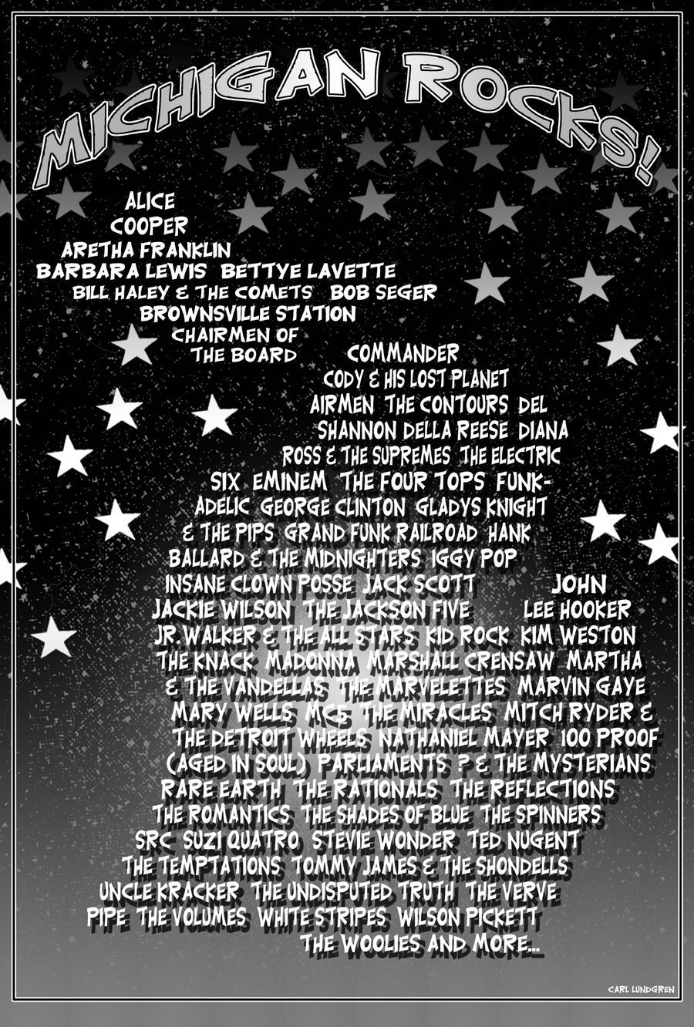

Part Rock Doc, part VH1 Behind the Music, your Michigan Rocks! vodcast will feature a randomly drawn profile artist AND an examination of their artistic contributions and defining place in music—and cultural—history.

In addition to writing an original short biography on the musician/band:
- identify what the artist is best known for
- analyze some of their critically acclaimed music contributions
- discuss how they were influenced/how they influenced others
- explore societal events (time capsule the era)
- compare and contrast some of the artist’s groundbreaking work with more contemporary music (definitely tied to influence)

Ex. Alice Cooper pioneered shock rock & theatrics, which heavily influenced bands such as KISS and Motley Crue. Do some research & discuss it in detail.

Using iPhoto and iMovie, you and your partner will create a vodcast which:
- uses your refined and revised Michigan Rocks research notes as a script for the narrative voiceover track (audio)
- accomplishes a congruency between high-quality, subject-relevant images and the narrative audio track
- includes photo edits, effects, and transitions, which enhance your project
- competes against your peers’ projects in our Battle of the Bands March Madness-style single elimination tourney.

This is a research project. You are the authority. Become the expert. Teach!

- Alice Cooper
- Al Green
- Anita Baker
- Aretha Franklin
- Berry Gordy, Jr.
- Bill Haley & The Comets
- Bob Seger
- The Contours
- Dell Shannon
- Diana Ross & The Supremes
- Eminem
- The Four Tops
- George Clinton Parliament Funkadelic
- Gladys Knight & The Pips
- Grand Funk Railroad
- Hank Ballard & The Midnighters
- Iggy Pop & The Stooges
- Jack Scott
- Jackie Wilson
- The Jackson Five
- John Lee Hooker
- Jr. Walker & The All Stars
- Kid Rock
- Kim Weston
- The Knack
- Madonna
- Marshall Crensaw
- Martha & The Vandellas
- Marvin Gaye
- Mary Wells
- MC5
- The Miracles (Smokey Robinson)
- Mitch Ryder & The Detroit Wheels
- Nathaniel Mayer
- Rare Earth
- The Rationals
- Rodriguez
- The Romantics
- The Spinners
- Stevie Wonder
- Ted Nugent
- The Temptations
- Tommy James & The Shondells
- Uncle Kracker
- The Verve Pipe
- White Stripes
- Wilson Pickett

- Chuck Berry
- James Brown
- Johnny Cash
- Ray Charles
- Fats Domino
- Bob Dylan
- Buddy Guy
- Buddy Holly
- Robert Johnson
- BB King
- Jerry Lee Lewis
- Roy Orbison
- Elvis Presley
- Little Richard
- Muddy Waters

