Q 3 Extra Credit
Language Arts 7—Kaye

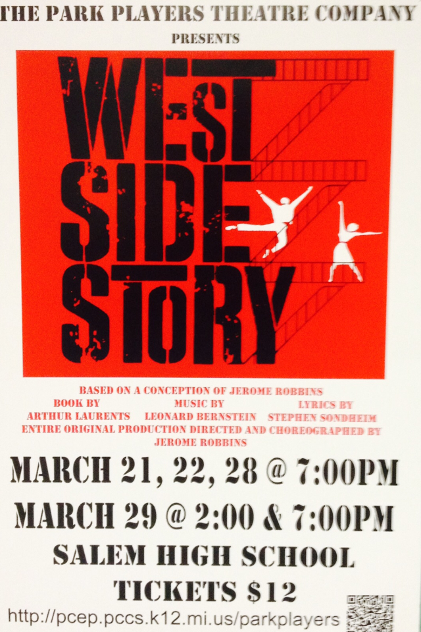

What happens when you throw The Outsiders, Rebel Without a Cause, and Romeo & Juliet into a blender? You have West Side Story—a tale of teenagers searching for opportunity and acceptance on the mean streets on NYC in the 1950s. West Side Story is considered by many to be the greatest overall American musical ever produced.

Here’s an extra credit opportunity for students to directly apply to either their position paper or their Outsiders/Rebel quiz. That’s right: 5 grade-booster points are on the line—just in time for some end-of-Q3 relief.

There are 2 ways to get the extra credit:
- Attend a live performance of West Side Story, presented by PCEP Players
- If you can’t attend a live performance, watch the classic film

After catching the action (live or on screen), print, complete & return this form to Mr. Kaye by Friday, April 4—the last day of Q3.
-- -- -- -- -- -- -- -- -- -- -- -- -- -- -- -- -- -- -- -- -- -- -- -- -- -- -- -- -- -- -- -- -- -- --

Student: _______________________________________________ Hour: ______

I saw West Side Story: the live PCEP production the film
circle one

In 4-5 sentences, provide your opinion of West Side Story and briefly compare and contrast it with The Outsiders and Rebel Without a Cause.

_____________________________________________________________________________________________________________________________________________________________________________________________________________________________________________________________________________________________________________________________________________________________________________________________________________________________________________________________________________________________________________________________________________ ___________________________________________
parent signature

